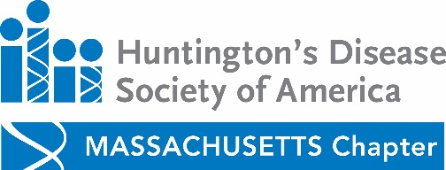

Massachusetts Family Education Symposium

Saturday, Nov 5th^{th} 2016
Tewksbury Hospital 365 East St Saunders Building Room Tewksbury Mass
There is no charge for parking

9:00: Registration, continental breakfast, visit exhibit booths

9:30: History of Mass Chapter, Ida Gold, Former Mass Chapter Board Member and Kara Keegan, SW

9:45: Research Update, Dr. Samuel Frank, MD

10:30: Progression toward Palliative Care, Nina Miranda NP

11:00 Tips and Tricks for Living Well with HD Julie MacLean, OTR/L Stacey Sullivan Lowell, MS CCC-
SLP

11:45: Lunch

12:15: Ask the Doc with Dr. Stephen Hersch, MD

1:00: Family Planning IVF- Dr. Kristen Wright from IVF New England

1:45: Community Resources by Kara Keegan. LICSW and Ciara Giney

2:15 Advocacy, Attorney Stephen Roche

2:30 Evaluations

$10 pp Register by Nov. 2nd at http://hdsa.donordrive.com/event/Maedday16/

Contact Stacey Lynn Sullivan staceylynn.sullivan@gmail.com with questions or if you prefer to register by mail.

This program is funded by the Huntington’s Disease Society of America through an unrestricted educational grant from Teva.

